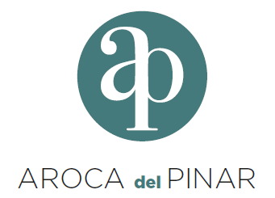
Calle Nanclares de Oca 1, 1B Madrid (SPAIN)
http://arocadelpinarsocimi.es/

PRESS RELEASE
AROCA DEL PINAR SOCIMI, S.A.

Madrid, 13th July 2026

Pursuant to Article 17 of Regulation (EU) No. 596/2014 of the European Parliament and of the Council of 16th April 2014 on market abuse (Market Abuse Regulation), and Article 61004/2 of Euronext Rule Book I, on ongoing obligations of companies listed on Euronext, AROCA DEL PINAR SOCIMI, S.A. ("the Company") hereby notifies the following:

PRESS RELEASE

HEREF V SUB HOLDING S.à.R.L., duly represented, and in its condition as sole shareholder of AROCA DEL PINAR SOCIMI, S.A. resolved to approve a dividend distribution in his favor on the 29th of June 2026 against the result of the business year 2025 according to the following timetable and details:

Last trading date | 17/07/2026
Ex – Date | 20/07/2026
Record Date | 21/07/2026
Payment date | 22/07/2026
Total gross dividend (€) | 4,105,578.88
Number of issued shares with dividend rights: | 5,000,187
Gross amount (€ per share) | 0.821085067
Withholding tax (€ per share) | 0.082108507
Net amount (€ per share) | 0.738976561

The paying agent will be UPTEVIA OST CENTRALISEES, and payment will be made through the means that EUROCLEAR makes available to its participating entities.

We remain at your disposal for any clarifications you may require.

Yours faithfully,

EUGER INVESTMENTS, S.L.U., represented by Mr. Gisleno Eugenio Castro Tato
Secretary non-director
AROCA DEL PINAR SOCIMI, S.A.

