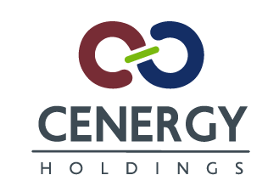

PRESS RELEASE OF CENERGY HOLDINGS SA
Brussels, 16 January 2017 5:40 PM

The enclosed information constitutes inside information and is to be considered regulated information as defined in the Belgian Royal Decree of 14 November 2007 regarding the duties of issuers of financial instruments which have been admitted for trading on a regulated market.

Disclosure of home member state

In compliance to the provisions of the Greek Law 3556/2007 and the Belgian Royal Decree of 14 November 2007, Cenergy Holdings SA informs the investor community that its home member state is Belgium.

*
About Cenergy Holdings

Cenergy Holdings is a Belgian holding company listed on both Euronext Brussels and Athens Exchange, investing in leading industrial companies, focusing on the growing global demand of energy transfer, renewables and data transmission. The Cenergy Holdings portfolio consists of Corinth Pipeworks and Hellenic Cables, companies positioned at the forefront of their respective high growth sectors. Corinth Pipeworks is a world leader in steel pipe manufacturing for the oil and gas sector and major producer of hollow sections for the construction sector. Cablel® Hellenic Cables is one of the largest cable producers in Europe, manufacturing power and telecom cables as well as submarine cables for the aforementioned sectors. For more information about our company, please visit our website at www.cenergyholdings.com.

